Rebekah Puttick
r.puttick@newcastle.ac.uk
Twitter: @rebekahputtick
LinkedIn: linkedin.com/in/rebekah-puttick-248560134

Bio

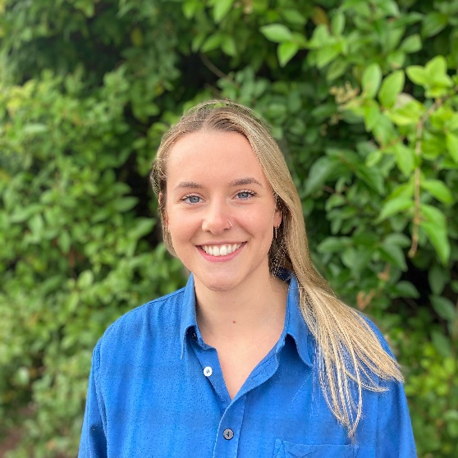
Growing up surrounded by green space, a fascination with animals throughout my formative years, and a healthy dose of millennial climate anxiety: these three factors have jointly contributed to my passion for conservation ecology. My research experience to date has explored several conservation strategies including rewilding and peatland restoration, utilising a range of research techniques from the ecological modelling and remote-sensing disciplines. Over the course of my PhD, I will build on this experience to explore the application of reforestation as a conservation strategy in a tropical context. Through this, I hope to contribute to the restoration and longevity of one of the most important and diverse ecosystems.

Research Questions

My PhD will gather important baseline data on habitat use my large-bodied mammal disperser species for a dedicated study area located in Sarawak, Malaysian Borneo. Such species are important for a multiplicity of reasons; they are important indicators of forest condition, can influence floral and faunal compositions of their ecosystems, and play an important role in carbon sequestration. This data will be used to address the following questions:
- How do mammal species respond to their environment (e.g., size of forest patch, distance to palm oil plantation)?
- Without constraints, can the reforestation process be spatially optimised to improve the connectivity of the landscape for disperser species?
- Considering financial, logistical, or ecological, constraints, how should this restoration process be strategized spatially?

Techniques

The research for my PhD will adopt a GIS and remote-sensing based methodology, combining camera trap data with environmental and spatial data to model the use of my study landscape by large-bodied mammal disperser species. The work will involve the spatial optimization of camera trap study design, functional trait modelling, ecological modelling of mammal responses to environmental gradients, and connectivity modelling with subsequent restoration scenario mapping.

Supervisors

Newcastle University: Dr Marion Pfeifer, Professor Yit Arn Teh
Northumbria University: Dr Miranda Prendergast-Miller, Dr Andrew Suggitt

CASE Partner

My research is in collaboration with the Sarawak Oil Palm Berhad (SOPB).
Publications

T. Gopalakrishna, T. Christmann, M. Pashkevich, R. Puttick (in press). Young voices in and visions for tropical restoration science in the UN Decade of Restoration.

Talks

ATBC 2021 Annual Meeting: Open Format Session “Young voices and visions in tropical restoration science”

NHSN 2020: “Rewilding at the Pleistocene Park”

